System Requirements Statement (SRS) –

Online Vehicle Service Station

1. Introduction 3

2. Functional Requirements 4

2.1 customer module 5

2.2 owner Module 11

2.3 employee Module 17

2.4 ADMIN Module 21

2.5 Use Case Diagram.............................................................................................................................22

THIS DOCUMENT CONTAINS 23 NUMBERED PAGES

# Introduction

This document explains the system requirements and scope for developing Online Vehicle Service Station System.

OVSS System could divide the four main parts, Customer, Owner part, Admin part and the Employee part.

This document describes the system requirement of the Account part.

# Functional Requirements

The Account part of Online Vehicle Service Station System has four modules which are divided into 19 processes described as below.

|  |  |  |
| --- | --- | --- |
| **No** | **BRS requirement ID** | **Description** |
| **2.1** | **Customer Module** | |
| **2.1.1** | **F1** | **Account Creation Process** |
| **2.1.2** | **F2** | **Login Process** |
| **2.1.3** | **F3** | **Forgot Password Process** |
| **2.1.4** | **F4** | **Change Password Process** |
| **2.1.5** | **F5** | **Update Account Process** |
| **2.1.6** | **F6** | **Search Workshops/Garages Nearby** |
| **2.1.7** | **F7** | **Book Appointment** |
| **2.1.8** | **F8** | **View Service Status** |
| **2.1.9** | **F9** | **View Invoice** |
| **2.1.10** | **F10** | **Give Feedback** |
| **2.2** | **Owner Module** | |
| **2.2.1** | **F11** | **Login Process** |
| **2.2.2** | **F13** | **Upload Information About Services** |
| **2.2.3** | **F14** | **Confirm Service Request of Customer** |
| **2.2.4** | **F15** | **Create Accounts For Employee** |
| **2.2.5** | **F16** | **Assign Task to Employee** |
| **2.2.6** | **F17** | **Manage Stock** |
| **2.2.7** | **F18** | **View Feedbacks** |
| **2.3 Employee Module** | | |
| **2.3.1** | **F17** | **Login Process** |
| **2.3.2** | **F18** | **Change Password Process** |
| **2.3.3** | **F19** | **View Different Service Requests** |
| **2.3.4** | **F20** | **Update Status of Services** |
| **2.3.5** | **F21** | **Generate Invoice** |
| **2.3.6** | **F22** | **Update Stock Related Info** |
| **2.4 Admin Module** | | |
| **2.4.1** | **F22** | **Login Process** |
| **2.4.2** | **F23** | **Forgot Password Process** |
| **2.4.3** | **F24** | **Change Password Process** |
| **2.4.4** | **F25** | **Update Account Process** |
| **2.4.5** | **F26** | **Add Owner** |
| **2.4.6** | **F27** | **Disable/Enable Accounts** |
| **2.4.7** | **F28** | **Generate Report** |

## Customer Module

* Customer is the user of system who wants to get his vehicle serviced/repaired.

* He is also able to view the rates/charges of servicing and feedbacks given by other customers to nearby service centers.
* When customer decides a particular service center to go forward with, he should be asked to login if an existing customer or should create new account if new customer.

### Account Creation Process

* OVSS System compels to create the account before using it. So, System should provide the function which makes Customer creates new account.
* When customer creates new account, the function demands four information described as below.

1. Login information
2. Contact Details
3. Vehicle Details

* The Login information

The Login information consists of some items described as below.

1. UserID
2. Password
3. First Name
4. Last Name
5. E-mail address
6. User Type
   * All items are compulsory demanded.
   * UserID

* The UserID should be unique. If the UserID correspond with not case-sensitive to other which is previously registered, the UserID should not be registered as an account.
  + Password
* The Password has constraints which makes the Password consists of more than or equal 8 and less than or equal 16 characteristics including characters described as below.

1. Numeric figure (at least one)
2. Capital alphabet (A-Z)(at least one)
3. Small alphabet (a-z)(at least one)
4. Special character (#, $, %, &, etc.) (at least one)

* The Password is masked by dummy characters. The re-entering Password is demanded.
* The Password must be encrypted in OVSS System.
* Contact Details
* The Contact Detail consists of some items described as below.

1. Current Address
2. Contact Phone No
   * All items are compulsory demanded.
   * Current Address

* Current Address should be filled.
* But only the state should be selected from options.
* The Security Question information

The Security Question information is needed when customer lost their Password. This information consists of two items described as below.

1. Selected Question
2. Answer
   * All items are compulsory demanded.
   * Some questions which are difficult to answer for anyone else are prepared in advance.

E.g. which color do you like most?

* + A question should be selected from options by the customer, and the Answer is registered by the customer.
* Login information should be entered on one screen, and then customer information and Security Question information should be entered on another screen.

### Login Process

* OVSS System always compels user authentication before using itself except when a new account is successfully created.
* The user authentication demands UserID and Password. The UserID and the Password should be checked in two ways.
  + First, The UserID and the Password should be existed and correct.
* If The UserID and the Password are not equal to what the user has registered, the user authentication cannot be provided.
  + Second, the User Type linked to the UserID should be "customer".
* When the User Type is "customer", then user can be placed on “Customer Home”.
* The customer account should alive for so long as the duration decided by Admin.
* Only when the two checks are successfully completed, customer can be placed on respected page.
* The “Customer Home” provides the some items described as below.

1. A trigger to logout
2. A trigger to update Account
3. A trigger to Change Password
4. A trigger to Search Nearby Service Stations
5. A trigger to view service history
6. A trigger to view current service details
7. A trigger to view invoice
8. A trigger to give feedback

### Forgot Password Process

* When system user lost their Password, the recovery method should be provided by OVSS system.

The recovery method is described as below.

* + First, system user enters their UserID for OVSS System.
  + Next, OVSS System demands the Answer which has been registered since when the Account was created.
  + Only when the Answer is correct, Customer get the new password by E-mail which also has been registered since when the Account was created.
  + The new password is automatically generated by OVSS System.
* Of course, the new password should consist of more than or equal 8 and less than or equal 16 characteristics including at least a numeric figure, a capital alphabet, a small alphabet, and a special character.
* As a consequence, The Customer could get the authentication using the new password.
  + Then, the Customer had better change the new password manually.
* If the Answer is not correct, otherwise, the correct Answer is demanded for user again.
  + In that case, Of course, customer couldn’t get the new password.

### Change Password Process

* When customer wants to change their Password, the measure should be provided by OVSS System.
* Therefore, OVSS System should provide the function which is available after getting the customer authentication.
* The function demands the current password and the new password.
  + Of course, the new password should consist of more than or equal 8 and less than or equal 16 characteristics including at least a numeric figure, a capital alphabet, a small alphabet, and a special character.
  + The current password and the new password are masked by using dummy characters.
  + The new password is demanded to enter twice to avoid a typing error.
* Only when the current password is correct, customer could change their Password.
* When the current password is changed into new password, OVSS System compels user authentication again.

### Update Account Process

* OVSS System should provide the function which makes the account updated for customer.
* The information customer could update is described below.

1. Login information
2. User information
3. Security Question Information

* The Login information

The updatable items as described below.

1. First Name
2. Last Name
3. E-mail address
   * All items are compulsory demanded, but updating is optional.

* The User information

The updatable items as described below.

1. User Name
2. User Phone No
3. E-mail address
4. Current address
   * All items are compulsory demanded, but updating is optional.

* The Security Question information

The updatable items as described below.

1. Selected Question
2. Answer
   * All items are compulsory demanded, but updating is optional.

**2.1.6 Search for Nearby Service Stations**

* OVSS System should show nearby service stations available to customer’s location.
* Customer will get a search bar on home page where system will ask customer to enter area or city he is currently in.
* OVSS system will show all the available service stations with their detailed address and respective ratings and reviews given by other customers.

**2.1.7**  **Book Appointment**

* Whenever customer searches for service centers nearby, system should provide option of booking appointment with the same service center he decides to go on after reviewing their ratings and feedbacks.
* At the time of booking an appointment system should ask customer to verify vehicle and address details he have provided at the time of registering his account on OVSS system.
* System should also ask vehicle type to user and should show services available with their rates according to vehicle type customer have selected.
* Customer should be able to select multiple services or other vehicle related works shown in the list to his cart.
* At last System should also provide option of vehicle pickup and drop from customers location and time slot according to customer’s feasible time.

**2.1.8**  **View Service Status**

* System will provide a link for customer to view current service status.
* The service status will be updated as per updates given by employees of garage or garage owner itself.
* Customer will be able to see current service details with status marked as In-Progress or Completed.

**2.1.9 View Invoice**

* System will provide a link for customer to view invoice generated by service center after completion of a services or other vehicle works requested by customer.
* Customer will be able to see list of all his previous invoices of different service centers with completion date and time.

**2.1.10**  **Give Feedback**

* System should ask customer to provide feedback and star ratings based on the current servicing experience.

## Owner Module

**2.2.1 Login Process**

* Online Vehicle Service Station always compels Owner’s authentication before using itself except when a new account is successfully created.
* The user authentication demands UserID and Password. The UserID and the Password should be checked in three ways.
  + First, The UserID and the Password should be existed and correct.
* If The UserID and the Password are not equal to what the user has registered, the user authentication cannot be provided.
  + Second, the User Type linked to the UserID should be "user".
* When the User Type is " Owner ", user can be placed on “Owner Home”.
  + Finally, UserID should be available.
* The Administrator can decide whether the UserID is available or suspended – Refer to the SRS of the Admin part.
* If user is rejected, user authentication is not provided for Owner.
* The Owner account should alive for so long as the duration decided by Admin.
* Only when the three checks are successfully completed, Owner can be placed on respected page.
* The “Owner Home” provides some items described as below.

1. A trigger to logout
2. A trigger to Upload/Update information about services
3. A trigger to view & approve servicing requests of customer
4. A trigger to create accounts for employees
5. A trigger to add stocks
6. A trigger to manage feedback

**2.2.2 Upload Information About Services**

* System should provide facility for owner to upload various services available in his own service center
* Owner can also be able to edit or modify existing services which he already has displayed to customer through OVSS system.
* Whenever Owner clicks on this tab, Owner should get below links

1. Upload New
2. Modify Existing

1)Upload New

* Whenever User click on this link, System should ask owner to provide following detail.
  + - * 1. Service id which should be auto generated by system
        2. Service Name
        3. Service category (can select from drop down)
        4. Service cost (must be positive)

2)Modify Existing

* After clicking on this link, owner should get all the existing services he has listed before.
* The list of services should show detailed information about service he has entered while creating it.
* With all the information listed, owner should get links beside each service for edit and deleting the existing service.
* Owner should be able to edit information such as service name, category and cost/rate.

**2.2.3 Confirm Service Request of Customer**

* When Customer request for booking an appointment for the servicing of his own vehicle, the same request should be visible to owner under this tab.
* The Request should show all the detailed information such as
  + - * + Customers Name
        + Customers Address
        + Vehicle Type
        + Vehicle company
        + Vehicle Number
        + Service Types
* To accept the request depends on situation like employee’s availability and number of service request received on same day.
* If employees are available/free and request received are less than 5, then owner can accept the request and system should send the booking confirmation to customer with.
* If there are no employees available/free or request counts are more than 5 for the day then owner can reject the request and should convey the same message to customer suggesting alternate days available.

**2.2.4 Create Account for Staff**

* OVSS system should provide a feature of creating new accounts for his new employees.
* The details required for creating accounts should be provided by employee manually at the time of joining the service station.
* The details required are as follows
  + - * + Full Name of employee
        + Current address
        + Contact details (mobile and email)
* Owner should verify above details provided by employee and should generate account id and default password for employee logins.
* Owner should also be able to edit information/accounts for employees through OVSS system.

**2.2.5 Assign Task To Employee**

* Owner should be able to assign the task of confirmed requests of customer to employee whoever is available for that moment.
* System should provide a hyper link for owner along with the confirmed request for assigning the same request task.
* Whenever owner clicks on that link, system should request owner to select particular employee’s ID from dropdown menu.
* As soon as owner assigns the task, the same assigned task should be visible to employee under view services window.

**2.2.5 Manage Stock**

* Whenever owner click on add stock, system should be able to add new stock related information in existing stock database
* Owner should select stock id and stock name from dropdown and should add quantity for the corresponding stock item.
* Also owner should be able edit the existing stock information such quantity as well as price

**2.2.6 View Feedbacks**

* OVSS system should provide access to view all feedbacks given by the customer.
* The View feedback page should show details as Customer details, servicing type, servicing date, and actual feedback text
* Owner should be able to review or revert to customers on the same feedbacks given.

## Employee Module

**2.3.1 Login Process**

* OVSS System always compels Employee authentication before using itself.
* The user authentication demands UserID and Password. The UserID and the Password should be checked in three ways.
  + First, The UserID and the Password should be existed and correct.
* If The UserID and the Password are not equal to what the user has registered, the user authentication cannot be provided.
  + Second, the User Type linked to the User-ID should be "user".
* When the User Type is " Employee ", user can be placed on “Employee Home”.
  + Finally, User-ID should be available.
* The Administrator can decide whether the User-ID is available or suspended – Refer to the SRS of the Admin part.
* If user is rejected, user authentication is not provided for Employee.
* The Employee account should alive for so long as the duration decided by Admin.
* Only when the three checks are successfully completed, Employee can be placed on respected page.
* The “Employee Home” provides some items described as below.
* A trigger to logout
* A trigger to Change Password
* A trigger to View Different Services Request
* A trigger to Update Status of Services
* A trigger to Update Stock Related Info

**2.3.2 Change Password Process**

* When Employee wants to change their Password, the measure should be provided by OVSS System.
* Therefore, OVSS System should provide the function which is available after getting the Wholesaler authentication.
* The function demands the current password and the new password.
  + Of course, the new password should consist of more than or equal 8 and less than or equal 16 characteristics including at least a numeric figure, a capital alphabet, a small alphabet, and a special character.
  + The current password and the new password are masked by using dummy characters.
  + The new password is demanded to enter twice to avoid a typing error.
* Only when the current password is correct, Employee could change their Password.
* When the current password is changed into new password, OVSS System compels Employee authentication again.

**2.3.3 View Different Service Request**

* Whenever Employee clicks on the view services link, system should show different service request of customers which are approved by owner and assigned to that particular employee.
* Below are the details employee could see along with the service request

1. Customer and vehicle details
2. Service type

**2.3.4 Update Status Of Services**

• Employee can update the status of services as per work completion

1. Exact status of work that can be In-Progress or Completed

2. If it is in-progress then employee should provide or mention the estimated date and time required for completion of work.

**2.3.5 Generate Invoice**

* Whenever employee marks the status of service as complete on which he was working, System should ask employee to generate invoice for the same.
* This invoice should cover all the service cost along with tax, and should also forward the same invoice to customer through system.
* The invoice format should be as follows
* Customer information at heading section
* Invoice ID
* Creation Date
* Service description along with quantity, unit price, tax and total amount

**2.2.6 Update Stock Related info.**

• Employee can update stock related information to system

1. How much stock is available in stocks.

2. Quantity of stock to be required in future.

3. Immediate requirement of stocks.

4. Info about current stock is sufficient or not.

## Admin Module

**•** Administratorshould be responsible for following activities**.**

**2.4.1 Login Process**

* The user authentication demands User-ID and Password. The User-ID and the Password should be checked in three ways.
  + First, The User-ID and the Password should be existed and correct.
* If The User-ID and the Password are not equal to what the admin has registered, the Admin authentication cannot be provided.
  + Second, the User Type linked to the User-ID should be "Admin".
* When the User Type is "Admin", user can be placed on “Admin Home”.

s

* + Finally, User-ID should be available.
* The Administrator can decide whether the User-ID is available or suspended .
* Only when the three checks are successfully completed, Admin can be placed on respected page.
* The “Admin Home” provides the some items described as below.

1. A trigger to logout
2. A trigger to update Account
3. A trigger to Change Password
4. A trigger to Add Owners
5. A trigger to Disable/Enable Accounts
6. A trigger to Generate Reports

**2.4.2 Forgot Password Process**

* When Admin lost their Password, the recovery method should be provided by OVSS.

The recovery method is described as below.

* + First, Admin enters their User-ID for OVSS System.
  + He will enter the E-mail id since when the Account was created.
  + Only when the E-mail Id is correct, Admin get the new password by E-mail which also has been registered since when the Account was created.
  + The new password is automatically generated by OVSS System.
* Of course, the new password should consist of more than or equal 8 and less than or equal 16 characteristics including at least a numeric figure, a capital alphabet, a small alphabet, and a special character.
* As a consequence, The Admin could get the Admin authentication using the new password.
  + Then, the Admin had better change the new password manually.

**2.4.3 Change Password Process**

* When Admin wants to change his Password, the measure should be provided by OVSS System.
* Therefore, OVSS System should provide the function which is available after getting the Admin authentication.
* The function demands the current password and the new password.
  + Of course, the new password should consist of more than or equal 8 and less than or equal 16 characteristics including at least a numeric figure, a capital alphabet, a small alphabet, and a special character.
  + The current password and the new password are masked by using dummy characters.
  + The new password is demanded to enter twice to avoid a typing error.
* Only when the current password is correct, Admin could change his Password.
* When the current password is changed into new password, OVSS System compels user authentication again.

**2.4.4 Update Account Process**

* OVSS System should provide the function which makes the account updated for Admin.
* The information Admin could update is described below.

1. Login information
2. User information
3. Security Question Information

* The Login information

The updatable items as described below.

1. First Name
2. Last Name
3. E-mail address
   * All items are compulsory demanded, but updating is optional.

* The User information

The updatable items as described below.

1. User Name
2. User Phone No
3. E-mail address
4. Permanent address
   * All items are compulsory demanded, but updating is optional.

* The Security Question information

The updatable items as described below.

1. Selected Question
2. Answer
   * All items are compulsory demanded, but updating is optional.

**2.4.5 Add Owner**

* Whenever any owner decided to register his service station on OVSS system, he should request admin to create account along with all essential information.
* OVSS system should provide Admin an ownership of creating accounts for garage owners.
* Details to be filled by admin while creating an account for owner are as follows
* Owners full name
* Owners service stations Name and detailed address
* Contact details
* email
* After validating all the documents and details owner has provided during his manual request, Admin should create an account for owner and should provide userID and password along with approval mail.
* Admin can also reject the owners request if the documents provided by owner are not valid or incomplete.

**2.4.6 Disable/Enable Accounts**

* Admin should able to manage all the accounts with following activities,

1. Enable accounts

2. Disable accounts

**2.4.7 Report Generation**

* Admin should able to see all the feedbacks given to each service center and no of services provided by that service center and should generate performance report accordingly.

#### 2.5 Use Case Diagram

**Admin:**

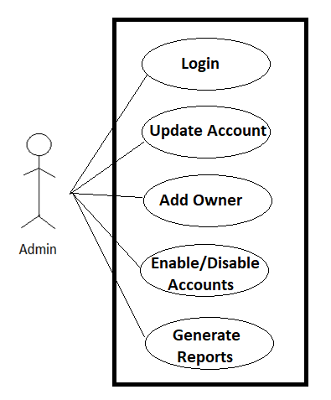

*Fig. Use case diagram for admin*

**Customer :**

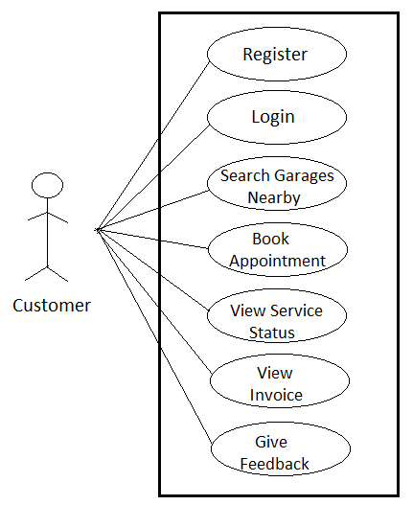

*Fig. Use case diagram for Customer*

**Employee :**

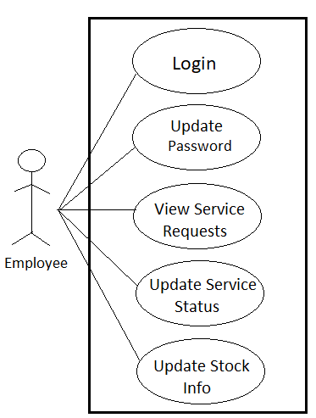

*Fig. Use case diagram for Employee*

**Owner :**

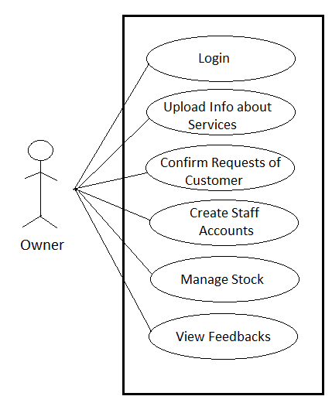

*Fig. Use case diagram for Owner*